Project Report: Customer Shopping Behaviour Analysis
1. Introduction
In the modern business environment, data analytics plays a crucial role in understanding customer behavior and improving decision-making. This project focuses on analyzing customer shopping patterns and transforming raw data into meaningful insights using Python, SQL, and Power BI.

2. Objective
- To analyse customer shopping behavior and trends
- To clean and preprocess raw data for accurate analysis
- To store structured data in a database
- To create an interactive dashboard for business insights

3. Tools & Technologies Used
- Python (Pandas, NumPy)
- MySQL (Database Management)
- Power BI (Data Visualization & Dashboarding)
- Jupyter Notebook

4. Project Workflow
- Data Collection
- Data Cleaning & Preprocessing (Python)
- Data Storage (MySQL Database)
- Data Visualization (Power BI Dashboard)

5. Dataset Description
The dataset includes:
- Customer Age
- Purchase Category
- Purchase Amount (USD)
- Purchase Frequency
- Review Ratings
- Discount Applied

6. Data Preprocessing (Python)
- Handled missing values using median imputation
- Renamed columns into standardized format (snake_case)
- Removed redundant columns (e.g., duplicate discount fields)
- Created new features:
  - Age Groups (Young Adults, Adults, etc.)
  - Purchase Frequency (converted into numerical days)

7. Database Integration (MySQL)
- Imported cleaned dataset into MySQL database
- Created structured tables for efficient data storage
- Enabled querying and integration with BI tools
8. Data Visualization (Power BI)
- Connected Power BI to MySQL database
- Built an interactive dashboard to visualize insights
Dashboard Highlights:
- Sales distribution by category
- Customer segmentation by age group
- Purchase frequency analysis
- Impact of discounts on sales
- Key KPIs (Total Sales, Average Rating, etc.)

9. Key Insights
- Certain product categories generate higher revenue
- Discounts significantly influence customer purchasing behavior
- Different age groups show distinct shopping patterns
- Frequent buyers contribute more to overall sales

10. Conclusion
This project demonstrates an end-to-end data analytics workflow, starting from raw data processing in Python, storing structured data in MySQL, and finally visualizing insights through Power BI dashboards. It highlights the importance of data-driven decision-making in business.

11. Future Scope
- Implement machine learning models for customer prediction
- Enhance dashboard with real-time data updates
- Perform advanced segmentation and recommendation systems

12. Project Outcome
- Developed practical experience in Python, SQL, and Power BI
- Built a complete data analytics pipeline
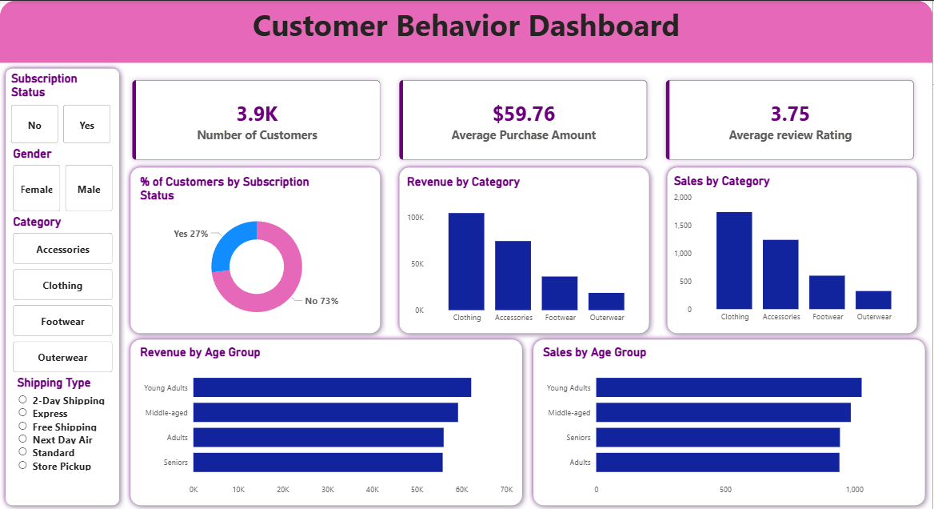
- Gained hands-on experience in dashboard creation.

